**How To Install Window 11**



Session: 2022 – 2026

**Submitted by:**

M Awais Ashraf 2022-CS-186

**Supervised by:**

Sir Numan Shafi

Department of Computer Science

**University of Engineering and Technology**

**Lahore Pakistan**

# Steps:

* Check your laptop Specifications for Win 11
* Install win11 iso file
* Insert a USB and make it bootable by rufus
* Restart laptop in which you want to install win 11
* Press Ese or F2 to select bootable USB

## Follow these Pictures:

* 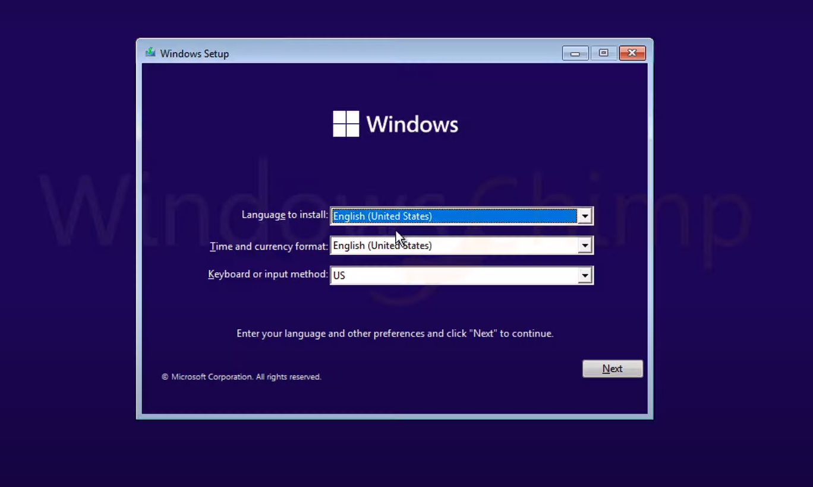Press Next

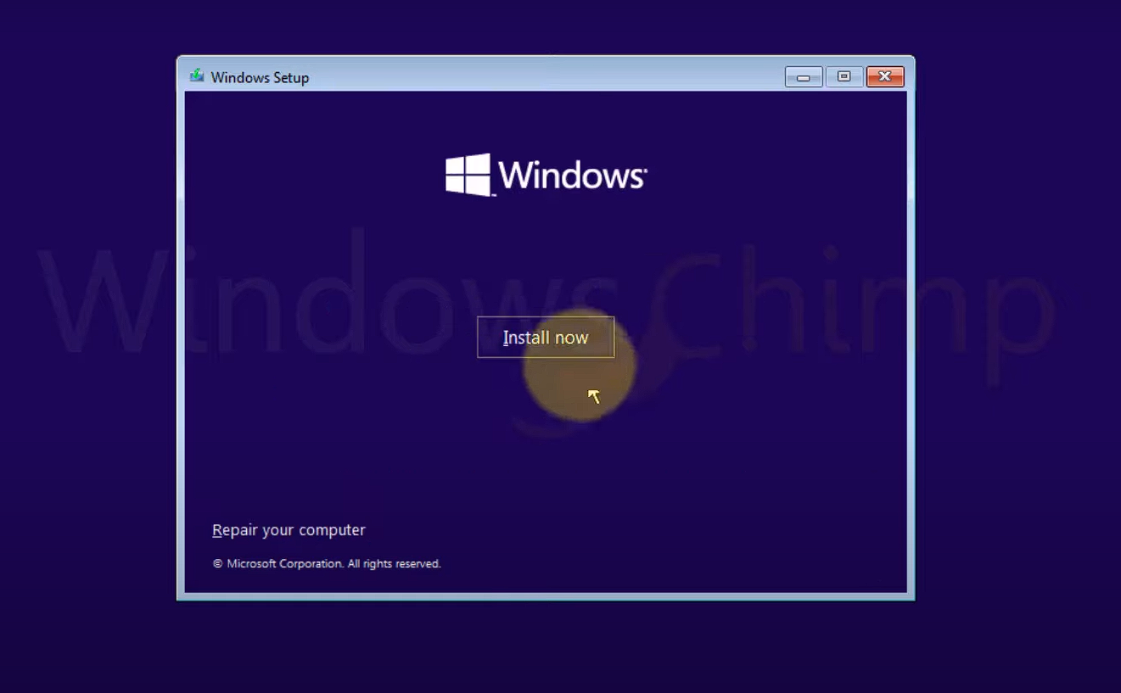



* 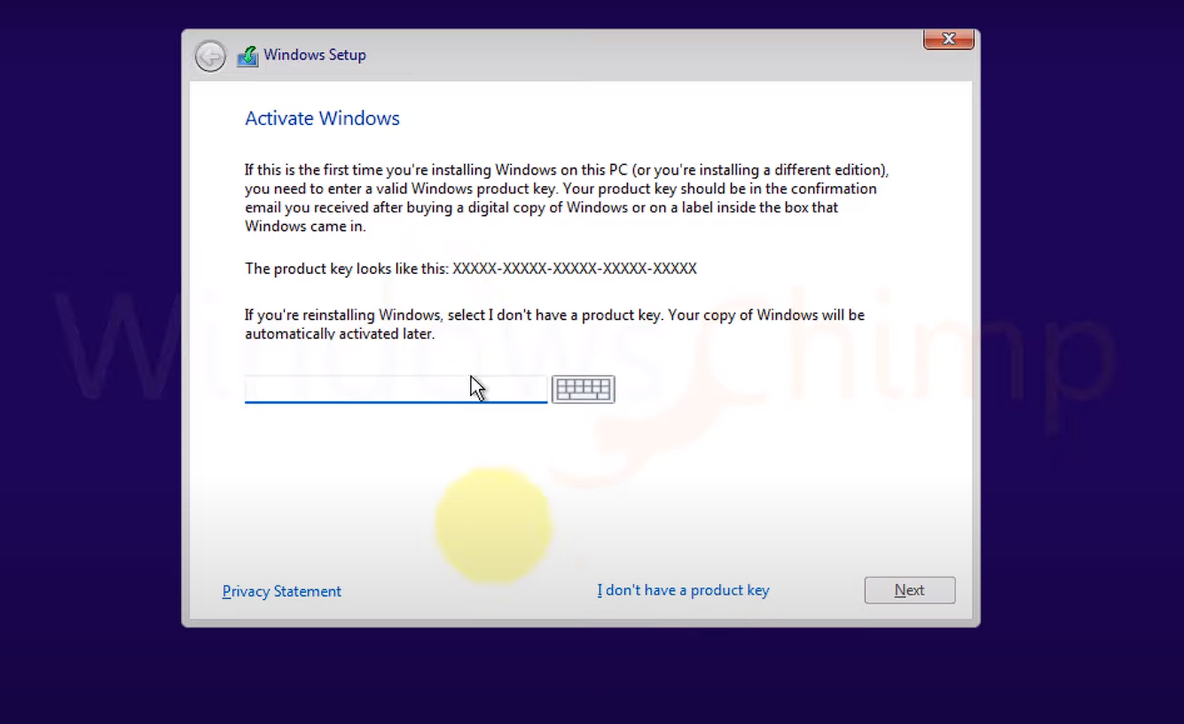Press I do not have license Key
* 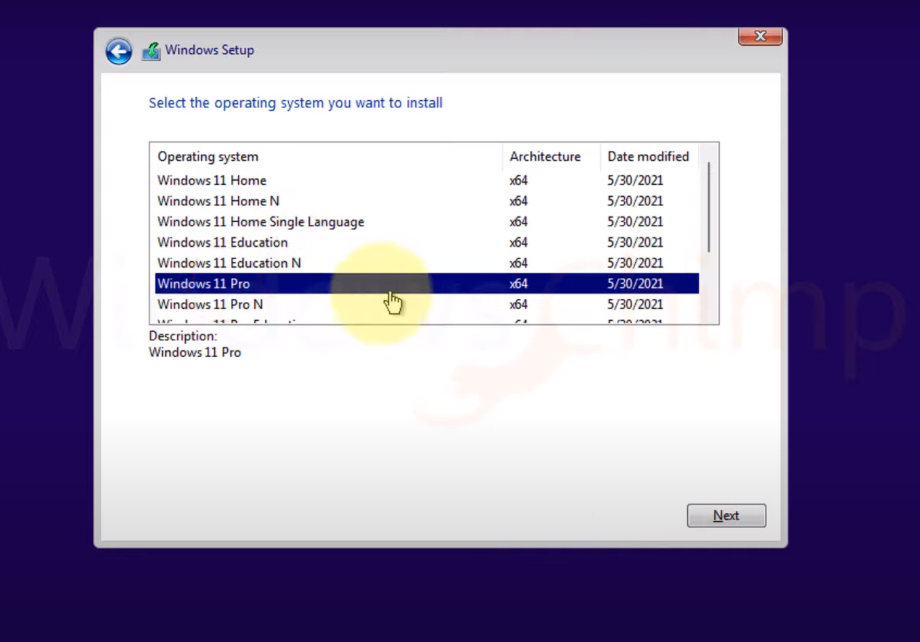Select Window Edition

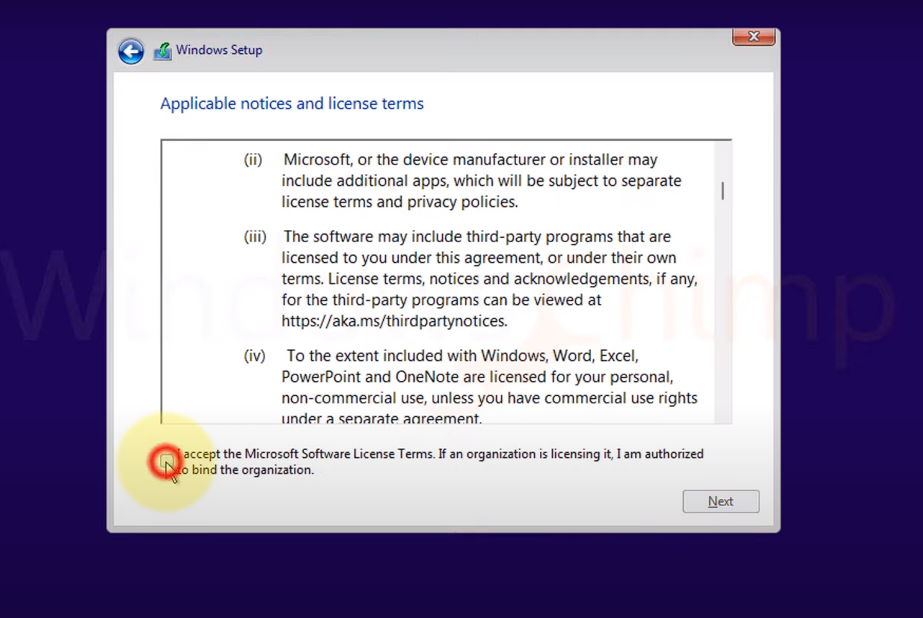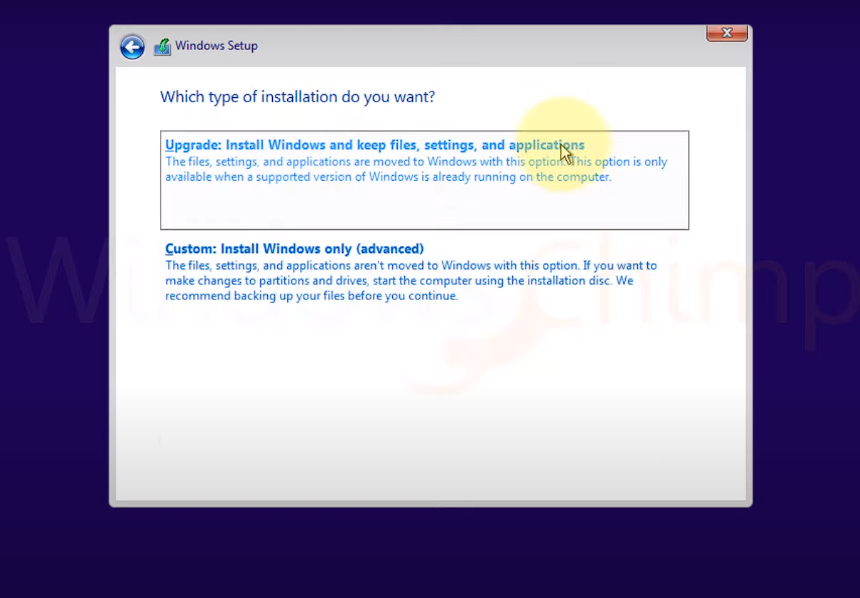

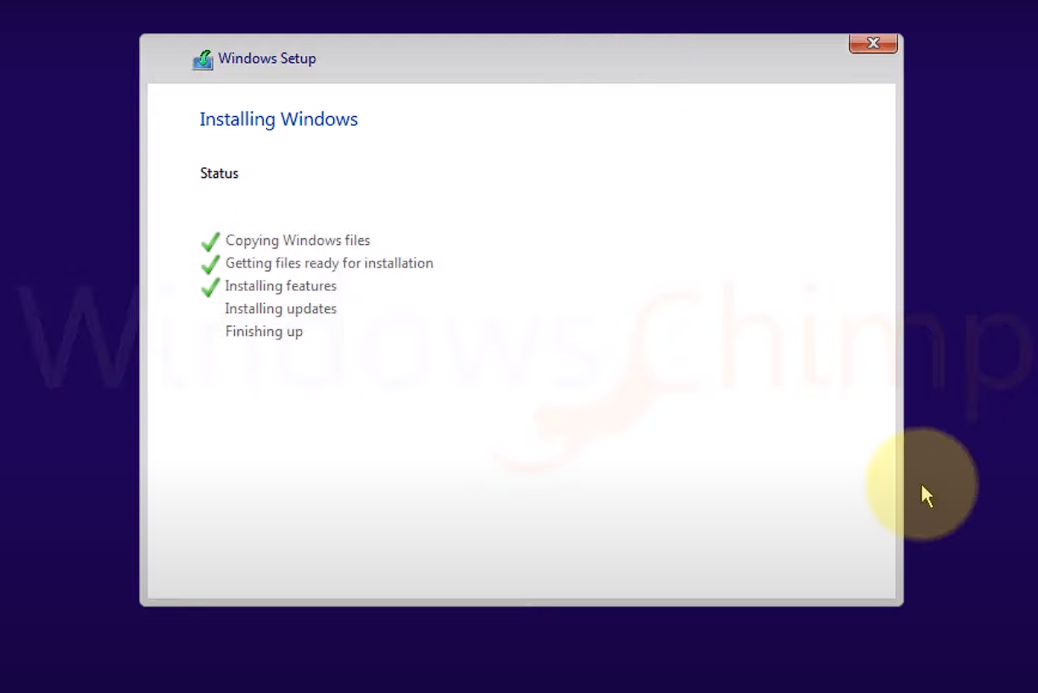

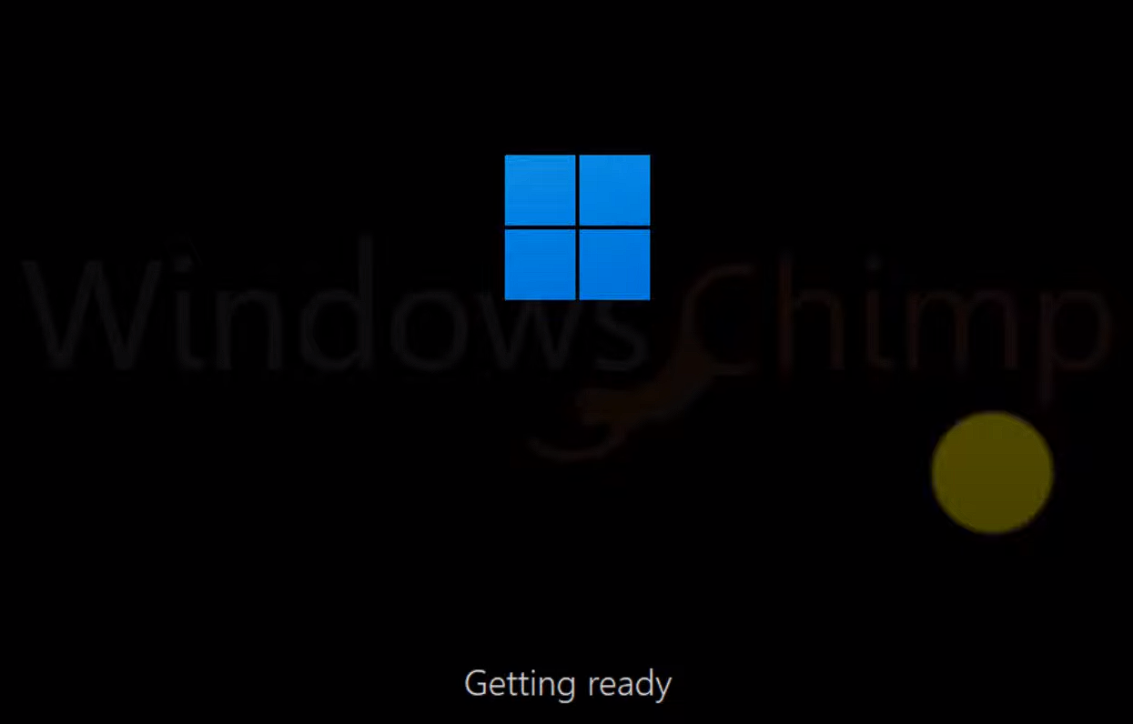

### My Laptop Specifications:

* Hp Elitebook Amd Ryzene 5 Pro (4650U) 845 G7
* 12-Logical Processors
* 6-Core
* Ram 16Gb
* Ssd 512Gb
* Graphics card 512mb Redeon

